Ryan Smith
015792504
CMPE-146 Sec 01
17 November 2023
Lab 6
Exercise 1 UART
Exercise 1.1 Send text string
1.)
In the following function I declare a pointer to the transmit buffer register and a pointer to the status register. I then have a while loop that runs until it reaches the null byte in the msg being sent. During the loop it checks if the busy bit is 1, and if it is not busy or 0, then the current character in the msg array is sent to the transmit buffer register. It then increments to the next character in the array.
void send_message(char *msg)
{
//set pointers to buffer and status
uint16_t *txbuf = (uint16_t *)(EUSCI_A0_BASE + 0x0E);
uint16_t *statw = (uint16_t *)(EUSCI_A0_BASE + 0x0A);

//loop until msg reaches null byte
while(*msg != '\0')
{
//check if the busy bit is 0
if(*statw == 0x00)
{
//send character to buffer
*txbuf = *msg++;
}
}
}

2.)
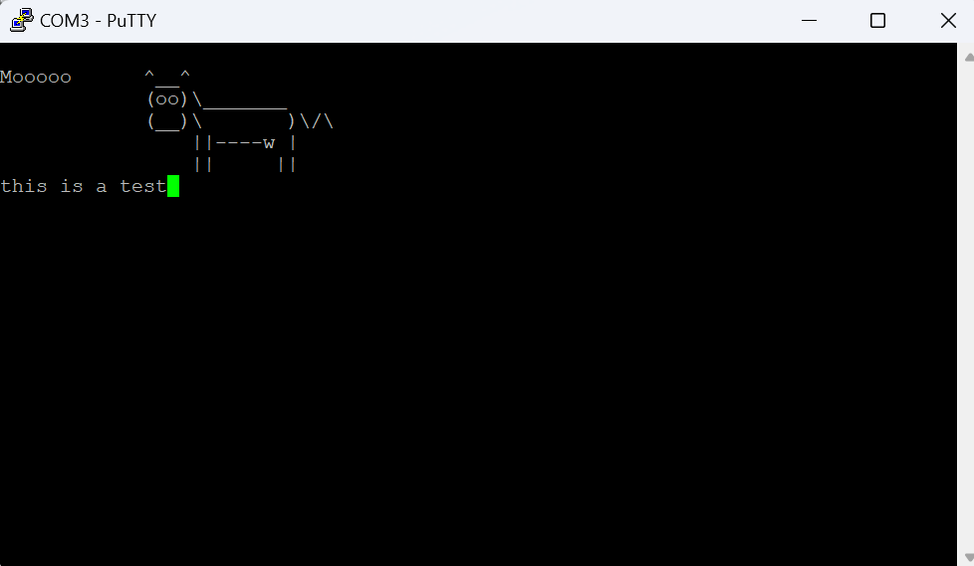

Exercise 1.2 Emulate UART
1.)
In the following code, there is the defined baud rate and the delay calculated based on this baud rate. In the send_message function, it while loops until it reaches a null terminator byte, it then sets the Tx pin low to signify the start bit. It then delays for the calculated number of cycles based on the baud rate. It then goes through each bit in the current character, starting at the LSB, and checks if that bit is 1 or 0, setting the Tx line to high or low corresponding with the value of the bit. After each bit is transmitted, it delays for the number of cycles calculated earlier. After all 8 bits are transmitted, it then moves to the next char in the array.

#define BAUD_RATE 9600

const uint32_t delay = (3000000 / BAUD_RATE) - 32;
void send_message(char *msg)
{
while(*msg != '\0')
{
//set output low on Tx pin to signal data transmission
GPIO_setOutputLowOnPin(GPIO_PORT_P1, GPIO_PIN3);
//delay
__delay_cycles(delay);

//for each bit in the character starting at lsb
uint32_t i;
for(i = 0; i < 8; i++)
{
//check if the bit is 1
if((*msg >> i) & 0x1)
{
//set Tx to high if 1
GPIO_setOutputHighOnPin(GPIO_PORT_P1, GPIO_PIN3);
}
else
{
//set Tx to low if not 1
GPIO_setOutputLowOnPin(GPIO_PORT_P1, GPIO_PIN3);
}

//delay
__delay_cycles(delay);
}

//set output high to signal stop bit
GPIO_setOutputHighOnPin(GPIO_PORT_P1, GPIO_PIN3);
//delay
__delay_cycles(delay);

//move to next char in array
msg++;
}
}

2.)
In order to make the program work at 9600 baud, I decreased the delay by 32 to get it to work. I tested the program while decreasing the delay by increments of 2 in order to get it to work.

3.)
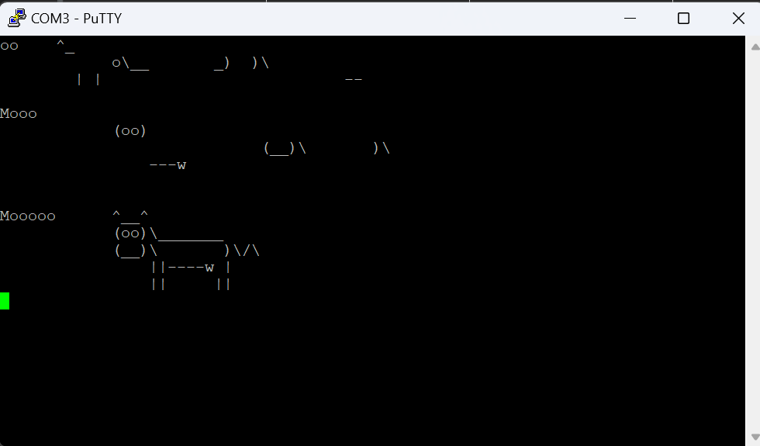

Exercise 1.3 Parity Bit
1.) In order to calculate the parity bit in the following code I count the number of bits set to 1 in the current character. Then if the parity is supposed to be odd or even, I check if the count of 1 bits divided by 2 has a remainder, and then I set the parity bit to 1 or 0 depending on if the parity is supposed to have an odd or even number of 1 bits. It then outputs this parity bit before the stop bit.

#define PARITY 2 // 0: none, 1: odd parity, 2: even parity

void send_message(char *msg)
{
while(*msg != '\0')
{
//set output low on Tx pin to signal data transmission
GPIO_setOutputLowOnPin(GPIO_PORT_P1, GPIO_PIN3);
//delay
__delay_cycles(delay);

//set count for # of 1s in char
uint32_t count = 0;

//for each bit in the character starting at lsb
uint32_t i;
for(i = 0; i < 8; i++)
{
//check if the bit is 1
if((*msg >> i) & 0x1)
{
//increment count
count += 1;
//set Tx to high if 1
GPIO_setOutputHighOnPin(GPIO_PORT_P1, GPIO_PIN3);
}
else
{
//set Tx to low if not 1
GPIO_setOutputLowOnPin(GPIO_PORT_P1, GPIO_PIN3);
}

//delay
__delay_cycles(delay);
}

//create variable to store parity bit
uint32_t parity = 0;
//check if parity is odd or even
if(PARITY == 1)
{
//if odd and remainder is 0 then make parity bit 1
if(count % 2 == 0)
{
parity = 1;
}
//already odd number so set parity bit to 0
else
{
parity = 0;
}
}
//if parity is even
else if(PARITY == 2)
{
//if remainder is 0 means already even so set parity bit to 0
if(count % 2 == 0)
{
parity = 0;
}
//if remainder is not 0 then not even so set parity bit to 1
else
{
parity = 1;
}
}
else{}

//check if there is supposed to be a parity bit
if(PARITY != 0)
{
//if parity bit is 1
if(parity)
{
//set output to high to transmit parity bit
GPIO_setOutputHighOnPin(GPIO_PORT_P1, GPIO_PIN3);
}
//if parity bit is 0
else
{
//set output low to transmit parity bit
GPIO_setOutputLowOnPin(GPIO_PORT_P1, GPIO_PIN3);
}
//delay
__delay_cycles(delay);
}

//set output high to signal stop bit
GPIO_setOutputHighOnPin(GPIO_PORT_P1, GPIO_PIN3);
//delay
__delay_cycles(delay);

//move to next char in array
msg++;
}
}

2.)
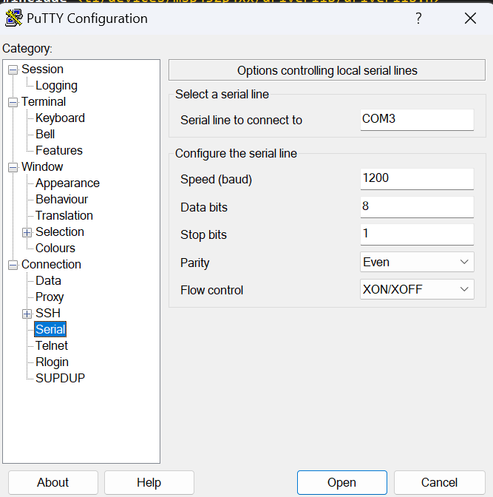
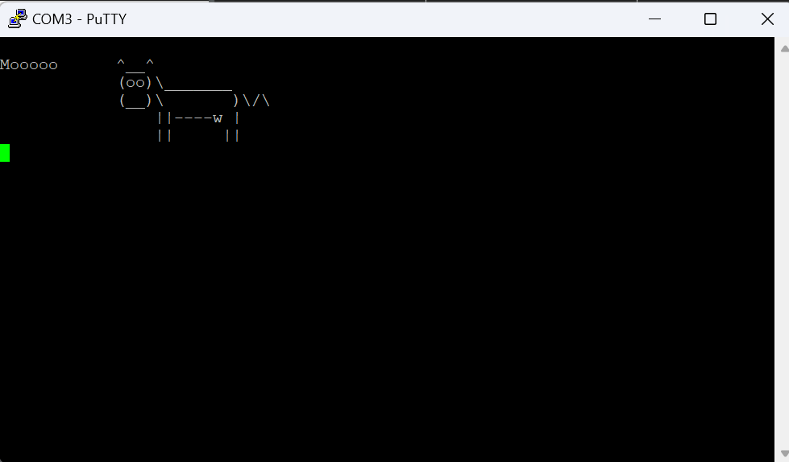

Exercise 2 EnergyTrace
Exercise 2.1 Energy measurements
1.)
Method | Measurement | Energy (mJ) | Mean Current (mA)
SW | 1 | 50.365 | 0.9536
 | 2 | 50.489 | 0.9549
 | 3 | 50.673 | 0.9552
 | Avg | 50.509 | 0.9545666667
HW | 1 | 4.525 | 0.907
 | 2 | 4.569 | 0.9064
 | 3 | 4.572 | 0.9025
 | Avg | 4.555333333 | 0.9053
DMA | 1 | 1.625 | 0.8914
 | 2 | 0.229 | 0.8653
 | 3 | 0.306 | 0.8628
 | Avg | 0.72 | 0.8731666667
DMA LPM | 1 | 0.23 | 0.6808
 | 2 | 0.23 | 0.6798
 | 3 | 0.178 | 0.6763
 | Avg | 0.2126666667 | 0.6789666667

2.)
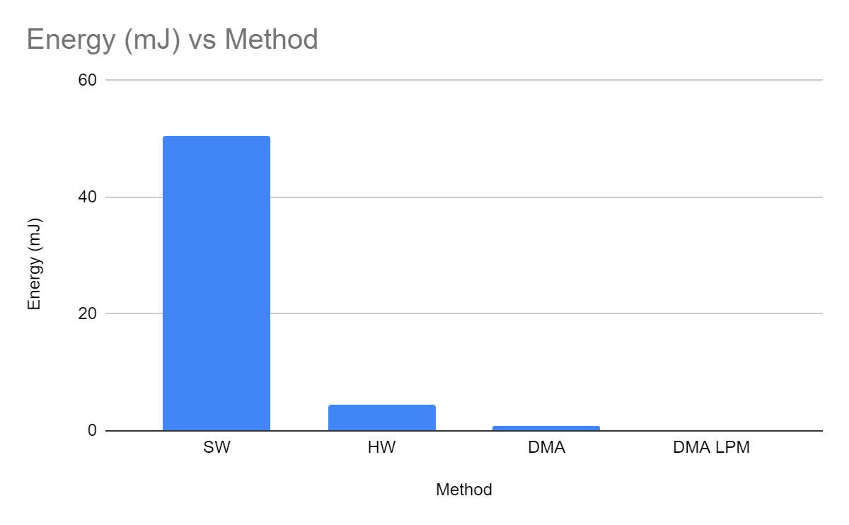

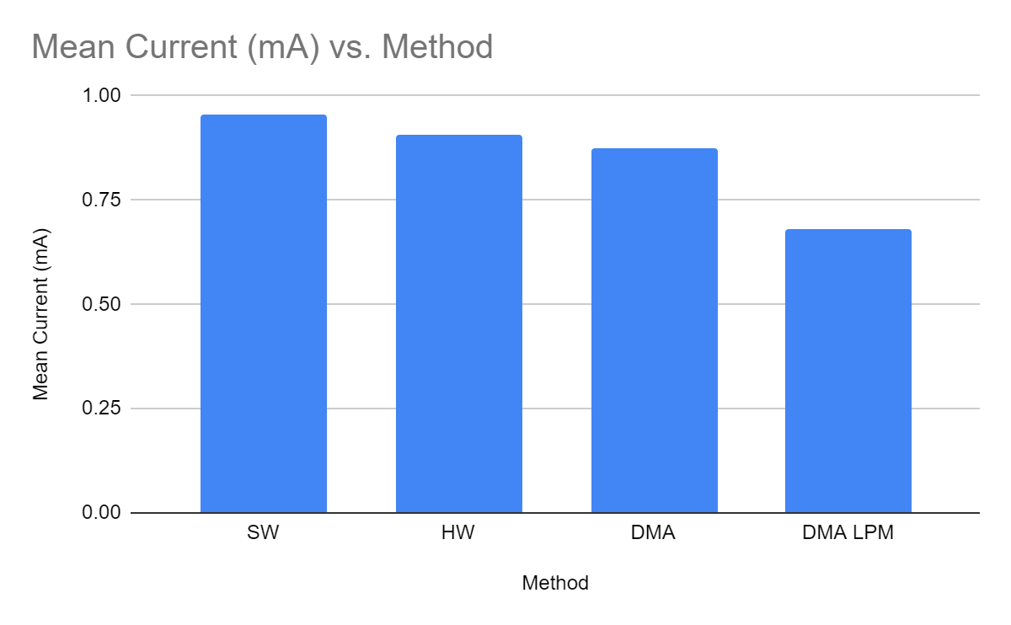

3.)
From the graphs we can see that software uses the most energy. The hardware method was 2nd most, while the DMA was 3rd most, and the DMA LPM mode used the least amount of energy. The SW method used the most amount of energy due to the CPU doing calculations and transferring data. The HW method used less energy because using an accelerator uses less energy than doing the calculations using the CPU. DMA is similar to the HW method, however, it does not use the CPU to transfer data between memory making it more efficient. The DMA LPM used the least amount of energy and current because the CPU goes into low power mode.

Exercise 2.2 LPM4.5
1.)
Method | Energy (mJ) | Mean Current (mA) |  | Method | Energy (mJ) | Mean Current (mA)
Interrupt | 0.27 | 0.1022 |  | Polling | 21.669 | 0.6566
 | 0.27 | 0.1149 |  |  | 21.666 | 0.6565
 | 0.282 | 0.1047 |  |  | 21.676 | 0.6568
Averages | 0.274 | 0.1072666667 |  |  | 21.67033333 | 0.6566333333

2.)
Energy savings = (21.67 - 0.274)/21.67 * 100 = 98.74%
Current savings = (0.656 - 0.107)/0.656 * 100 = 83.69%

Appendix
Exercise 1
Exercise 1.1 Program
/* DriverLib Includes */
#include <ti/devices/msp432p4xx/driverlib/driverlib.h>

/* Standard Includes */
#include <stdint.h>
#include <stdbool.h>

//![Simple UART Config]
/* UART Configuration Parameter. These are the configuration parameters to
* make the eUSCI A UART module to operate with a 9600 baud rate. These
* values were calculated using the online calculator that TI provides
* at:
*http://software-dl.ti.com/msp430/msp430_public_sw/mcu/msp430/MSP430BaudRateConverter/index.html
*/
const eUSCI_UART_ConfigV1 uartConfig =
{
EUSCI_A_UART_CLOCKSOURCE_SMCLK, // SMCLK Clock Source
78, // BRDIV = 78
2, // UCxBRF = 2
0, // UCxBRS = 0
EUSCI_A_UART_NO_PARITY, // No Parity
EUSCI_A_UART_LSB_FIRST, // LSB First
EUSCI_A_UART_ONE_STOP_BIT, // One stop bit
EUSCI_A_UART_MODE, // UART mode
EUSCI_A_UART_OVERSAMPLING_BAUDRATE_GENERATION, // Oversampling
EUSCI_A_UART_8_BIT_LEN // 8 bit data length
};
//![Simple UART Config]

void send_message(char *msg)
{
//set pointers to buffer and status
uint16_t *txbuf = (uint16_t *)(EUSCI_A0_BASE + 0x0E);
uint16_t *statw = (uint16_t *)(EUSCI_A0_BASE + 0x0A);

//loop until msg reaches null byte
while(*msg != '\0')
{
//check if the busy bit is 0
if(*statw == 0x00)
{
//send character to buffer
*txbuf = *msg++;
}
}
}

int main(void)
{
/* Halting WDT */
MAP_WDT_A_holdTimer();

/* Selecting P1.2 and P1.3 in UART mode */
MAP_GPIO_setAsPeripheralModuleFunctionInputPin(GPIO_PORT_P1,
GPIO_PIN2 | GPIO_PIN3, GPIO_PRIMARY_MODULE_FUNCTION);

/* Setting DCO to 12MHz */
CS_setDCOCenteredFrequency(CS_DCO_FREQUENCY_12);

//![Simple UART Example]
/* Configuring UART Module */
MAP_UART_initModule(EUSCI_A0_BASE, &uartConfig);

/* Enable UART module */
MAP_UART_enableModule(EUSCI_A0_BASE);

/* Enabling interrupts */
MAP_UART_enableInterrupt(EUSCI_A0_BASE, EUSCI_A_UART_RECEIVE_INTERRUPT);
MAP_Interrupt_enableInterrupt(INT_EUSCIA0);
MAP_Interrupt_enableSleepOnIsrExit();
MAP_Interrupt_enableMaster();
//![Simple UART Example]

static char something[] =
{0x0d,0x0a,0x4d,0x6f,0x6f,0x6f,0x6f,0x6f,0x20,0x20,0x20,0x20,0x20,0x20,0x5e,0x5f,
0x5f,0x5e,0x0d,0x0a,0x20,0x20,0x20,0x20,0x20,0x20,0x20,0x20,0x20,0x20,0x20,
0x20,0x28,0x6f,0x6f,0x29,0x5c,0x5f,0x5f,0x5f,0x5f,0x5f,0x5f,0x5f,0x0d,0x0a,0x20,
0x20,0x20,0x20,0x20,0x20,0x20,0x20,0x20,0x20,0x20,0x20,0x28,0x5f,0x5f,0x29,0x5c,
0x20,0x20,0x20,0x20,0x20,0x20,0x20,0x29,0x5c,0x2f,0x5c,0x0d,0x0a,0x20,0x20,
0x20,0x20,0x20,0x20,0x20,0x20,0x20,0x20,0x20,0x20,0x20,0x20,0x20,0x20,0x7c,0x7c,
0x2d,0x2d,0x2d,0x2d,0x77,0x20,0x7c,0x0d,0x0a,0x20,0x20,0x20,0x20,0x20,0x20,
0x20,0x20,0x20,0x20,0x20,0x20,0x20,0x20,0x20,0x20,0x7c,0x7c,0x20,0x20,0x20,0x20,
0x20,0x7c,0x7c,0x0d,0x0a,0x00};

send_message(something);

while(1)
{
MAP_PCM_gotoLPM0();
}
}

/* EUSCI A0 UART ISR - Echoes data back to PC host */
void EUSCIA0_IRQHandler(void)
{
uint32_t status = MAP_UART_getEnabledInterruptStatus(EUSCI_A0_BASE);

if(status & EUSCI_A_UART_RECEIVE_INTERRUPT_FLAG)
{
MAP_UART_transmitData(EUSCI_A0_BASE, MAP_UART_receiveData(EUSCI_A0_BASE));
}

}

Exercise 1.2 Program
/* DriverLib Includes */
#include <ti/devices/msp432p4xx/driverlib/driverlib.h>

/* Standard Includes */
#include <stdint.h>
#include <stdbool.h>
#include <stdio.h>
#define BAUD_RATE 9600

const uint32_t delay = (3000000 / BAUD_RATE) - 32;
void send_message(char *msg)
{
while(*msg != '\0')
{
//set output low on Tx pin to signal data transmission
GPIO_setOutputLowOnPin(GPIO_PORT_P1, GPIO_PIN3);
//delay
__delay_cycles(delay);

//for each bit in the character starting at lsb
uint32_t i;
for(i = 0; i < 8; i++)
{
//check if the bit is 1
if((*msg >> i) & 0x1)
{
//set Tx to high if 1
GPIO_setOutputHighOnPin(GPIO_PORT_P1, GPIO_PIN3);
}
else
{
//set Tx to low if not 1
GPIO_setOutputLowOnPin(GPIO_PORT_P1, GPIO_PIN3);
}

//delay
__delay_cycles(delay);
}

//set output high to signal stop bit
GPIO_setOutputHighOnPin(GPIO_PORT_P1, GPIO_PIN3);
//delay
__delay_cycles(delay);

//move to next char in array
msg++;
}
}

int main(void)
{
/* Stop Watchdog */
MAP_WDT_A_holdTimer();

//set P1.2 (Rx) as input
GPIO_setAsInputPin(GPIO_PORT_P1, GPIO_PIN2);

//set P1.3 (Tx) as output and set to idle state
GPIO_setAsOutputPin(GPIO_PORT_P1, GPIO_PIN3);
GPIO_setOutputHighOnPin(GPIO_PORT_P1, GPIO_PIN3);

//delay 100 ms
__delay_cycles(300000);

static char something[] =
{0x0d,0x0a,0x4d,0x6f,0x6f,0x6f,0x6f,0x6f,0x20,0x20,0x20,0x20,0x20,0x20,0x5e,0x5f,
0x5f,0x5e,0x0d,0x0a,0x20,0x20,0x20,0x20,0x20,0x20,0x20,0x20,0x20,0x20,0x20,
0x20,0x28,0x6f,0x6f,0x29,0x5c,0x5f,0x5f,0x5f,0x5f,0x5f,0x5f,0x5f,0x0d,0x0a,0x20,
0x20,0x20,0x20,0x20,0x20,0x20,0x20,0x20,0x20,0x20,0x20,0x28,0x5f,0x5f,0x29,0x5c,
0x20,0x20,0x20,0x20,0x20,0x20,0x20,0x29,0x5c,0x2f,0x5c,0x0d,0x0a,0x20,0x20,
0x20,0x20,0x20,0x20,0x20,0x20,0x20,0x20,0x20,0x20,0x20,0x20,0x20,0x20,0x7c,0x7c,
0x2d,0x2d,0x2d,0x2d,0x77,0x20,0x7c,0x0d,0x0a,0x20,0x20,0x20,0x20,0x20,0x20,
0x20,0x20,0x20,0x20,0x20,0x20,0x20,0x20,0x20,0x20,0x7c,0x7c,0x20,0x20,0x20,0x20,
0x20,0x7c,0x7c,0x0d,0x0a,0x00};

send_message(something);

while(1)
{

}
}

Exercise 1.3 Program
/* DriverLib Includes */
#include <ti/devices/msp432p4xx/driverlib/driverlib.h>

/* Standard Includes */
#include <stdint.h>
#include <stdbool.h>
#include <stdio.h>
#define BAUD_RATE 1200
const uint32_t delay = (3000000 / BAUD_RATE);
#define PARITY 2 // 0: none, 1: odd parity, 2: even parity

void send_message(char *msg)
{
while(*msg != '\0')
{
//set output low on Tx pin to signal data transmission
GPIO_setOutputLowOnPin(GPIO_PORT_P1, GPIO_PIN3);
//delay
__delay_cycles(delay);

//set count for # of 1s in char
uint32_t count = 0;

//for each bit in the character starting at lsb
uint32_t i;
for(i = 0; i < 8; i++)
{
//check if the bit is 1
if((*msg >> i) & 0x1)
{
//increment count
count += 1;
//set Tx to high if 1
GPIO_setOutputHighOnPin(GPIO_PORT_P1, GPIO_PIN3);
}
else
{
//set Tx to low if not 1
GPIO_setOutputLowOnPin(GPIO_PORT_P1, GPIO_PIN3);
}

//delay
__delay_cycles(delay);
}

//create variable to store parity bit
uint32_t parity = 0;
//check if parity is odd or even
if(PARITY == 1)
{
//if odd and remainder is 0 then make parity bit 1
if(count % 2 == 0)
{
parity = 1;
}
//already odd number so set parity bit to 0
else
{
parity = 0;
}
}
//if parity is even
else if(PARITY == 2)
{
//if remainder is 0 means already even so set parity bit to 0
if(count % 2 == 0)
{
parity = 0;
}
//if remainder is not 0 then not even so set parity bit to 1
else
{
parity = 1;
}
}
else{}

//check if there is supposed to be a parity bit
if(PARITY != 0)
{
//if parity bit is 1
if(parity)
{
//set output to high to transmit parity bit
GPIO_setOutputHighOnPin(GPIO_PORT_P1, GPIO_PIN3);
}
//if parity bit is 0
else
{
//set output low to transmit parity bit
GPIO_setOutputLowOnPin(GPIO_PORT_P1, GPIO_PIN3);
}
//delay
__delay_cycles(delay);
}

//set output high to signal stop bit
GPIO_setOutputHighOnPin(GPIO_PORT_P1, GPIO_PIN3);
//delay
__delay_cycles(delay);

//move to next char in array
msg++;
}
}

int main(void)
{
/* Stop Watchdog */
MAP_WDT_A_holdTimer();

//set P1.2 (Rx) as input
GPIO_setAsInputPin(GPIO_PORT_P1, GPIO_PIN2);

//set P1.3 (Tx) as output and set to idle state
GPIO_setAsOutputPin(GPIO_PORT_P1, GPIO_PIN3);
GPIO_setOutputHighOnPin(GPIO_PORT_P1, GPIO_PIN3);

//delay 100 ms
__delay_cycles(300000);

static char something[] =
{0x0d,0x0a,0x4d,0x6f,0x6f,0x6f,0x6f,0x6f,0x20,0x20,0x20,0x20,0x20,0x20,0x5e,0x5f,
0x5f,0x5e,0x0d,0x0a,0x20,0x20,0x20,0x20,0x20,0x20,0x20,0x20,0x20,0x20,0x20,
0x20,0x28,0x6f,0x6f,0x29,0x5c,0x5f,0x5f,0x5f,0x5f,0x5f,0x5f,0x5f,0x0d,0x0a,0x20,
0x20,0x20,0x20,0x20,0x20,0x20,0x20,0x20,0x20,0x20,0x20,0x28,0x5f,0x5f,0x29,0x5c,
0x20,0x20,0x20,0x20,0x20,0x20,0x20,0x29,0x5c,0x2f,0x5c,0x0d,0x0a,0x20,0x20,
0x20,0x20,0x20,0x20,0x20,0x20,0x20,0x20,0x20,0x20,0x20,0x20,0x20,0x20,0x7c,0x7c,
0x2d,0x2d,0x2d,0x2d,0x77,0x20,0x7c,0x0d,0x0a,0x20,0x20,0x20,0x20,0x20,0x20,
0x20,0x20,0x20,0x20,0x20,0x20,0x20,0x20,0x20,0x20,0x7c,0x7c,0x20,0x20,0x20,0x20,
0x20,0x7c,0x7c,0x0d,0x0a,0x00};

send_message(something);

while(1)
{

}
}
Exercise 2
Exercise 2.1 Program

Exercise 2.2 Program
/*******************************************************************************
* Program to blink the red LED with push button S1 in LPM4.5.
******************************************************************************/
/* DriverLib Includes */
#include <ti/devices/msp432p4xx/driverlib/driverlib.h>

/* Standard Includes */
#include <stdint.h>
#include <stdbool.h>
#include <stdio.h>

#define USE_POLLING
volatile int button_pressed = 0;

// Set up GPIO ports for maximizing power saving
void setup_all_GPIO_ports(bool set_state)
{
MAP_GPIO_setAsOutputPin(GPIO_PORT_PA, PIN_ALL16); // Ports 1 and 2
MAP_GPIO_setAsOutputPin(GPIO_PORT_PB, PIN_ALL16); // Ports 3 and 4
MAP_GPIO_setAsOutputPin(GPIO_PORT_PC, PIN_ALL16); // Ports 5 and 6
MAP_GPIO_setAsOutputPin(GPIO_PORT_PD, PIN_ALL16); // Ports 7 and 8
MAP_GPIO_setAsOutputPin(GPIO_PORT_PE, PIN_ALL16); // Ports 9 and 10
MAP_GPIO_setAsOutputPin(GPIO_PORT_PJ, PIN_ALL16);
MAP_GPIO_setOutputLowOnPin(GPIO_PORT_P2, PIN_ALL8);

if (set_state) // Do not set to known states if returning from LPM. Need to preserve them
{
MAP_GPIO_setOutputLowOnPin(GPIO_PORT_PA, PIN_ALL16);
MAP_GPIO_setOutputLowOnPin(GPIO_PORT_PB, PIN_ALL16);
MAP_GPIO_setOutputLowOnPin(GPIO_PORT_PC, PIN_ALL16);
MAP_GPIO_setOutputLowOnPin(GPIO_PORT_PD, PIN_ALL16);
MAP_GPIO_setOutputLowOnPin(GPIO_PORT_PE, PIN_ALL16);
MAP_GPIO_setOutputLowOnPin(GPIO_PORT_PJ, PIN_ALL16);
}
}

// Blink briefly an LED
void blink_LED(uint8_t port, uint8_t pin)
{
MAP_GPIO_setOutputHighOnPin(port, pin);
__delay_cycles(10 * 3000); // 10 ms at 3 MHz
MAP_GPIO_setOutputLowOnPin(port, pin);
}

// Set up for push button interrupt
void setup_push_button()
{
MAP_GPIO_setAsInputPinWithPullUpResistor(GPIO_PORT_P1, GPIO_PIN1);
#ifdef USE_POLLING
return;
#else
MAP_GPIO_interruptEdgeSelect(GPIO_PORT_P1, GPIO_PIN1, GPIO_HIGH_TO_LOW_TRANSITION);
MAP_GPIO_enableInterrupt(GPIO_PORT_P1, GPIO_PIN1);
MAP_Interrupt_enableInterrupt(INT_PORT1);
#endif
}

int main(void)
{
/* Halting the Watchdog */
MAP_WDT_A_holdTimer();

if (MAP_ResetCtl_getPCMSource() & RESET_LPM45) // Wake up from LPM4.5
{
MAP_ResetCtl_clearPCMFlags(); // Clearing the PCM Reset flags
PCM->CTL1 = PCM_CTL1_KEY_VAL; // Unlocking the latched GPIO/LPM configuration flag

setup_all_GPIO_ports(false);
setup_push_button();
if (button_pressed)
{
button_pressed = 0;
blink_LED(GPIO_PORT_P1, GPIO_PIN0);
}

while(1)
{
MAP_PCM_shutdownDevice(PCM_LPM45);
}
}

setup_all_GPIO_ports(true);
setup_push_button();

// GPIO setup for red LED
MAP_GPIO_setAsOutputPin(GPIO_PORT_P1, GPIO_PIN0); // Red LED
MAP_GPIO_setOutputLowOnPin(GPIO_PORT_P1, GPIO_PIN0);

while(1)
{
#ifdef USE_POLLING
//check if the button has been pressed
if(!(MAP_GPIO_getInputPinValue(GPIO_PORT_P1, GPIO_PIN1)))
{
//blink the red LED
blink_LED(GPIO_PORT_P1, GPIO_PIN0);

//wait for button to not be pressed
while(!(MAP_GPIO_getInputPinValue(GPIO_PORT_P1, GPIO_PIN1)));
}
#else
MAP_PCM_shutdownDevice(PCM_LPM45);
#endif
}
}

// Port1 interrupt handler
void PORT1_IRQHandler(void)
{
uint16_t status = MAP_GPIO_getEnabledInterruptStatus(GPIO_PORT_P1);
MAP_GPIO_clearInterruptFlag(GPIO_PORT_P1, status);

if (status & GPIO_PIN1)
button_pressed = 1;
}

